**Practical No: 1 – K means clustering.**

**Aim:**

Read a datafile grades_km_input.csv and apply k-means clustering.

**Datafile:**

<https://github.com/Mounaki/Clustering/blob/master/grades_km_input.csv>

**source code:**

# install required packages

install.packages("plyr") install.packages("ggplot2") install.packages("cluster") install.packages("lattice") install.packages("grid")

install.packages("gridExtra")

# Load the package

library(plyr) library(ggplot2) library(cluster) library(lattice) library(grid) library(gridExtra)

# A data frame is a two-dimensional array-like structure in which each column contains values of one variable and each row contains one set of values from each column.

grade_input=as.data.frame(read.csv("D:/2020/Big Data Analytics/Practical/grades_km_input.csv")) kmdata_orig=as.matrix(grade_input[, c ("Student","English","Math","Science")]) kmdata=kmdata_orig[,2:4] kmdata[1:10,]

# the k-means algorithm is used to identify clusters for k = 1, 2, .. . , 15. For each value of k, the WSS is calculated.

wss=numeric(15)

# the option n start=25 specifies that the k-means algorithm will be repeated 25 times, each starting with k random initial centroids

for(k in 1:15)wss[k]=sum(kmeans(kmdata,centers=k,nstart=25)$withinss)

plot(1:15,wss,type="b",xlab="Number of Clusters",ylab="Within sum of square")

#As can be seen, the WSS is greatly reduced when k increases from one to two. Another substantial reduction in WSS occurs at k = 3. However, the improvement in WSS is fairly linear fork > 3.

km = kmeans(kmdata,3,nstart=25) km

c( wss[3] , sum(km$withinss)) df=as.data.frame(kmdata_orig[,2:4]) df$cluster=factor(km$cluster) centers=as.data.frame(km$centers)

g1=ggplot(data=df, aes(x=English, y=Math, color=cluster )) + geom_point() + theme(legend.position="right") +

geom_point(data=centers,aes(x=English,y=Math, color=as.factor(c(1,2,3))),size=10, alpha=.3, show.legend =FALSE) g2=ggplot(data=df, aes(x=English, y=Science, color=cluster )) + geom_point () +geom_point(data=centers,aes(x=English,y=Science, color=as.factor(c(1,2,3))),size=10, alpha=.3, show.legend=FALSE) g3 = ggplot(data=df, aes(x=Math, y=Science, color=cluster )) + geom_point () + geom_point(data=centers,aes(x=Math,y=Science, color=as.factor(c(1,2,3))),size=10, alpha=.3, show.legend=FALSE) tmp=ggplot_gtable(ggplot_build(g1))

grid.arrange(arrangeGrob(g1 + theme(legend.position="none"),g2 +

theme(legend.position="none"),g3 + theme(legend.position="none"),top ="High School Student Cluster Analysis" ,ncol=1))

**output**

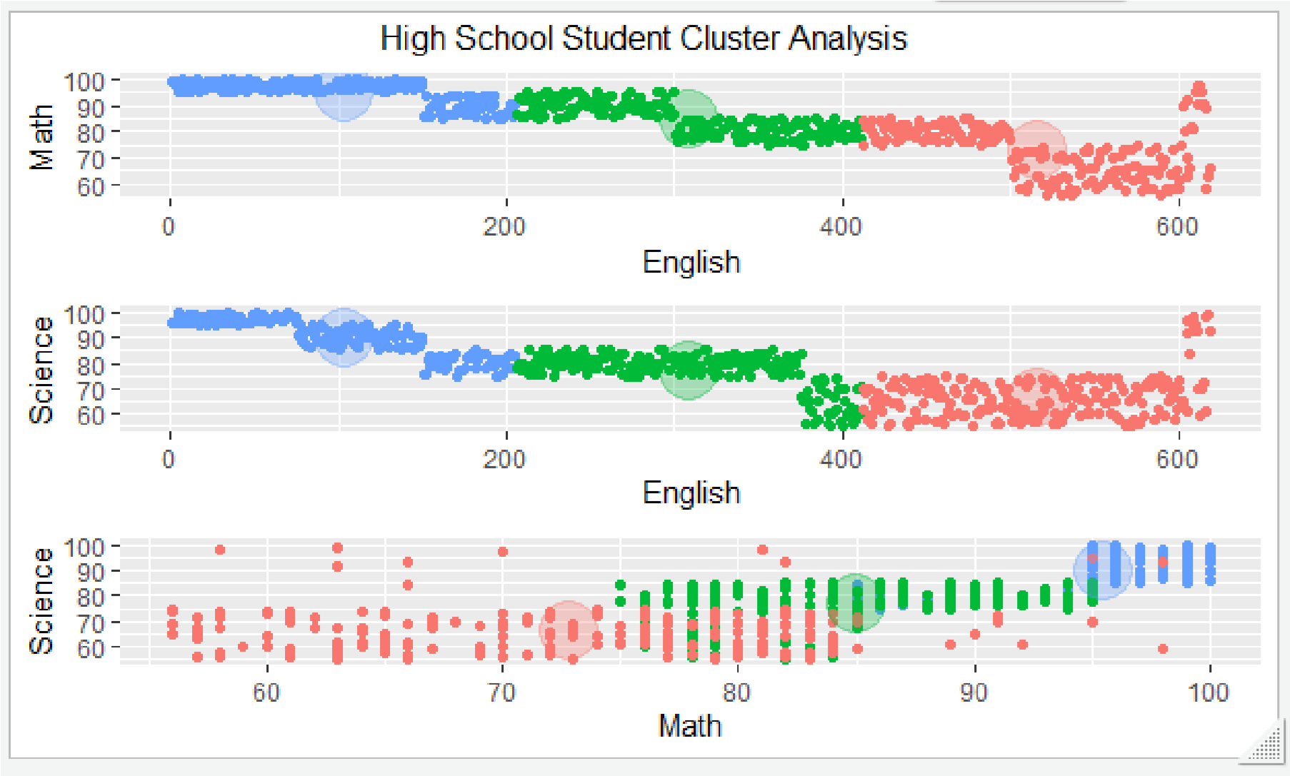

**Practical no 2: Apriori algorithm**

**Aim: Perform Apriori algorithm using Groceries dataset from the R arules package.**

**Code:**

install.packages("arules") install.packages("arulesViz")

install.packages("RColorBrewer")

# Loading Libraries library(arules) library(arulesViz)

library(RColorBrewer)

# import dataset data(Groceries)

Groceries

summary(Groceries)

class(Groceries)

# using apriori() function

rules = apriori(Groceries, parameter = list(supp = 0.02, conf = 0.2)) summary (rules)

# using inspect() function

inspect(rules[1:10])

# using itemFrequencyPlot() function arules::itemFrequencyPlot(Groceries, topN = 20, col = brewer.pal(8, 'Pastel2'), main = 'Relative Item Frequency Plot', type = "relative",

ylab = "Item Frequency (Relative)")

itemsets = apriori(Groceries, parameter = list(minlen=2, maxlen=2,support=0.02, target="frequent itemsets"))

summary(itemsets)

# using inspect() function inspect(itemsets[1:10])

itemsets_3 = apriori(Groceries, parameter = list(minlen=3, maxlen=3,support=0.02, target="frequent itemsets")) summary(itemsets_3)

# using inspect() function

inspect(itemsets_3)

output:

lhs rhs support confidence coverage lift count

1. {} => {whole milk} 0.25551601 0.2555160 1.00000000 1.000000 2513
2. {hard cheese} => {whole milk} 0.01006609 0.4107884 0.02450432 1.607682 99
3. {butter milk} => {other vegetables} 0.01037112 0.3709091 0.02796136 1.916916 102
4. {butter milk} => {whole milk} 0.01159126 0.4145455 0.02796136 1.622385 114
5. {ham} => {whole milk} 0.01148958 0.4414062 0.02602949 1.727509 113
6. {sliced cheese} => {whole milk} 0.01077783 0.4398340 0.02450432 1.721356 106
7. {oil} => {whole milk} 0.01128622 0.4021739 0.02806304 1.573968 111
8. {onions} => {other vegetables} 0.01423488 0.4590164 0.03101169 2.372268 140
9. {onions} => {whole milk} 0.01209964 0.3901639 0.03101169 1.526965 119 [10] {berries} => {yogurt} 0.01057448 0.3180428 0.03324860 2.279848 104

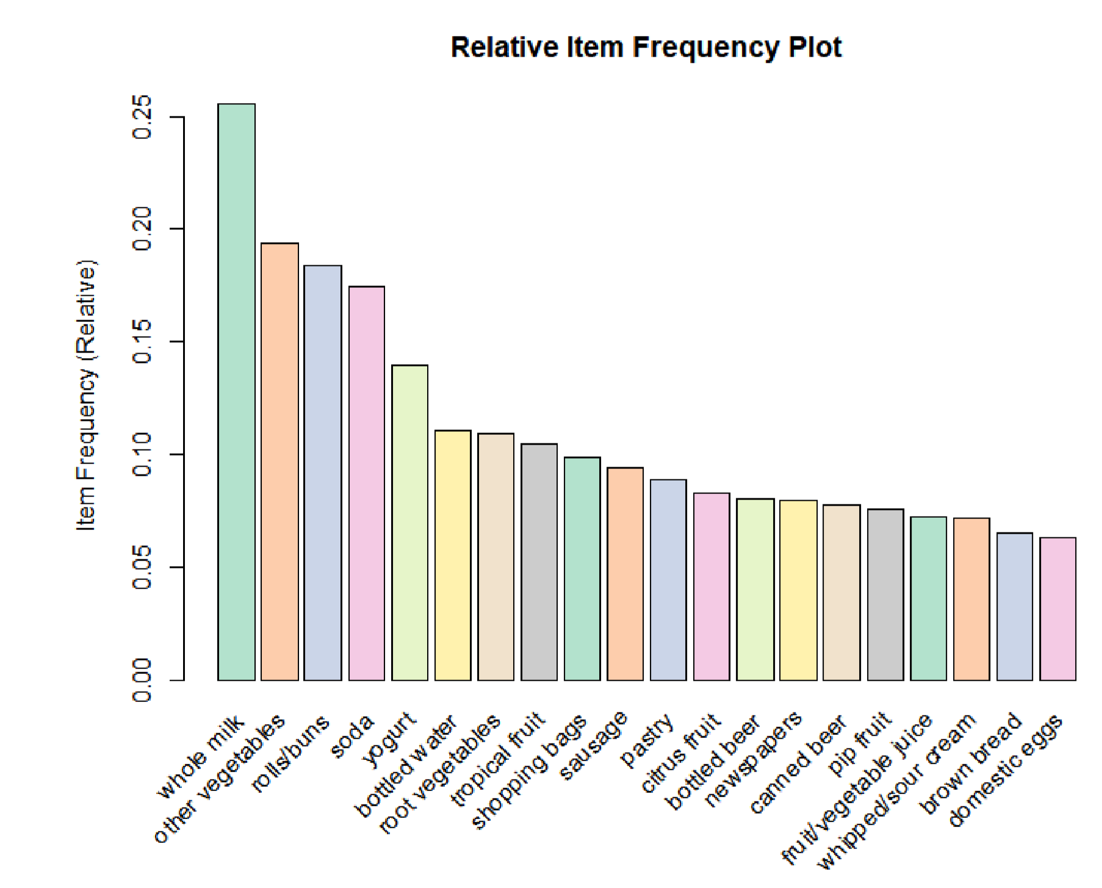

**Practical no: 3 Linear regression**

**Practical no: 3 a) Simple Linear regression**

**Aim: Create your own data for years of experience and salary in lakhs and apply linear regression model to predict the salary.**

**Code:**

years_of_exp = c(7,5,1,3)

salary_in_lakhs = c(21,13,6,8)

#employee.data = data.frame(satisfaction_score, years_of_exp, salary_in_lakhs) employee.data = data.frame(years_of_exp, salary_in_lakhs) employee.data

# Estimation of the salary of an employee, based on his year of experience and satisfaction score in his company.

model <- lm(salary_in_lakhs ~ years_of_exp, data = employee.data) summary(model)

# The formula of Regression becomes

# Y = 2 + 2.5*year_of_Exp

# Visualization of Regression

plot(salary_in_lakhs ~ years_of_exp, data = employee.data) abline(model)

**output:**

years_of_exp salary_in_lakhs

1. 7 21
2. 5 13
3. 1 6
4. 3 8

Residuals:

1. 2 3 4

1.5 -1.5 1.5 -1.5

Coefficients:

Estimate Std. Error t value Pr(>|t|) (Intercept) 2.0000 2.1737 0.92 0.4547

years_of_exp 2.5000 0.4743 5.27 0.0342 *

---

Signif. codes: 0 ‘***’ 0.001 ‘**’ 0.01 ‘*’ 0.05 ‘.’ 0.1 ‘ ’ 1

Residual standard error: 2.121 on 2 degrees of freedom

Multiple R-squared: 0.9328, Adjusted R-squared: 0.8993

F-statistic: 27.78 on 1 and 2 DF, p-value: 0.03417

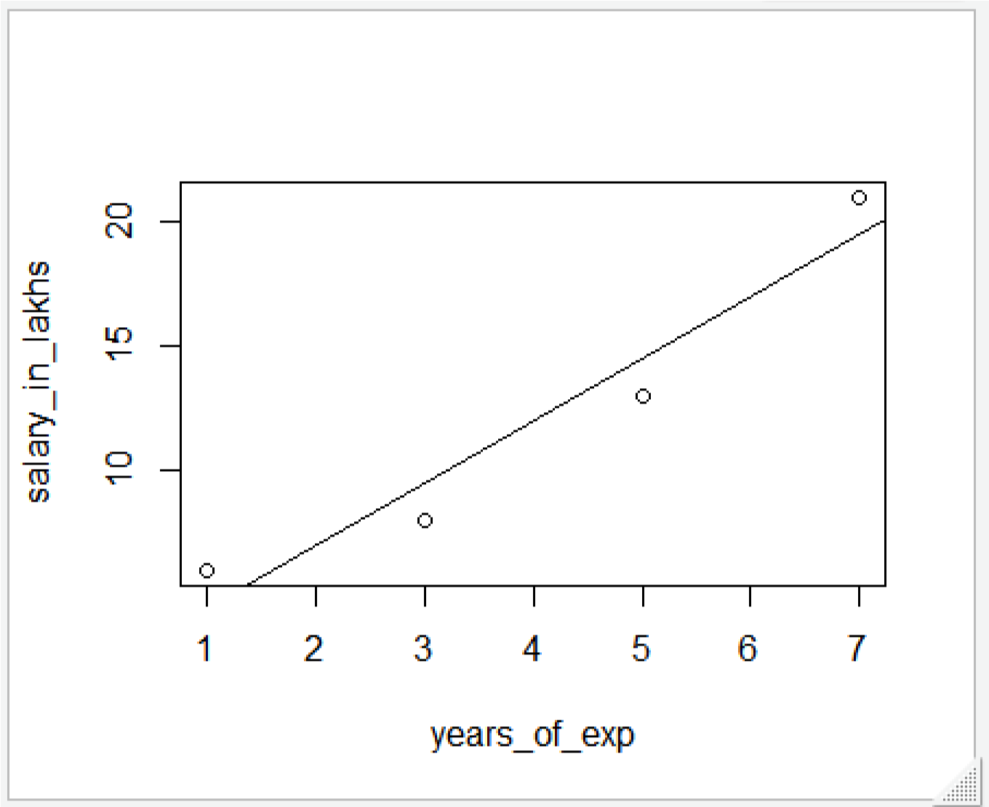

# b) Logistic regression

# Aim: Take the in-built data from ISLR package and apply generalized logistic regression to find whether a person would be defaulter or not; considering input as student, income and balance.

**Source code:**

install.packages("ISLR") library(ISLR)

#load dataset data <- ISLR::Default

print (head(ISLR::Default))

#view summary of dataset summary(data)

#find total observations in dataset

nrow(data)

#Create Training and Test Samples

#split the dataset into a training set to train the model on and a testing set to test the model set.seed(1)

#Use 70% of dataset as training set and remaining 30% as testing set sample <- sample(c(TRUE, FALSE), nrow(data), replace=TRUE, prob=c(0.7,0.3)) print (sample)

train <- data[sample, ]

test <- data[!sample, ]

nrow(train)

nrow(test)

# Fit the Logistic Regression Model

# use the glm (general linear model) function and specify family="binomial"

#so that R fits a logistic regression model to the dataset

model <- glm(default~student+balance+income, family="binomial", data=train)

#view model summary summary(model)

#Model Diagnostics

install.packages("InformationValue") library(InformationValue)

predicted <- predict(model, test, type="response")

confusionMatrix(test$default, predicted)

**output:**

> print (head(ISLR::Default)) default student balance income 1 No No 729.5265 44361.625 2 No Yes 817.1804 12106.135

1. No No 1073.5492 31767.139
2. No No 529.2506 35704.494
3. No No 785.6559 38463.496
4. No Yes 919.5885 7491.559

summary(data)

default student balance income No :9667 No :7056 Min. : 0.0 Min. : 772

Yes: 333 Yes:2944 1st Qu.: 481.7 1st Qu.:21340

Median : 823.6 Median :34553

Mean : 835.4 Mean :33517

3rd Qu.:1166.3 3rd Qu.:43808

Max. :2654.3 Max. :73554

> nrow(data)

[1] 10000

> print (sample)

[1] TRUE TRUE TRUE FALSE TRUE FALSE FALSE TRUE TRUE TRUE TRUE TRUE TRUE TRUE FALSE TRUE FALSE FALSE

[19] TRUE FALSE FALSE TRUE TRUE TRUE TRUE TRUE TRUE TRUE FALSE TRUE TRUE TRUE TRUE TRUE FALSE TRUE

> nrow(train)

[1] 6964

> nrow(test)

[1] 3036

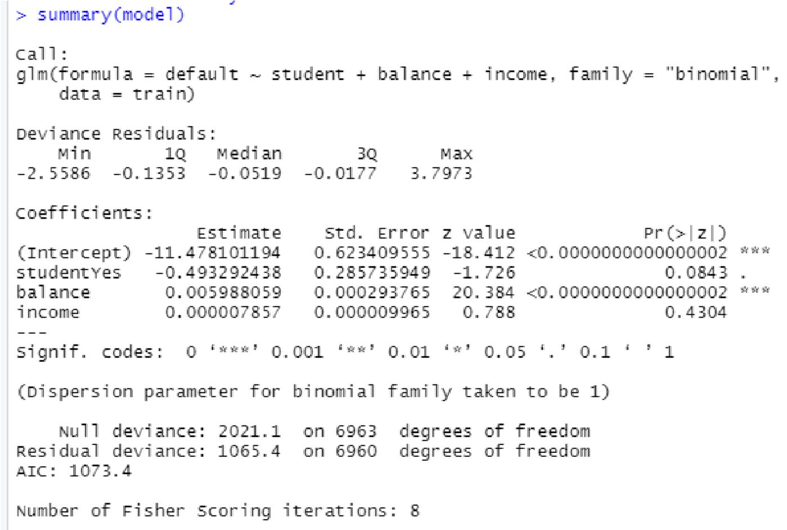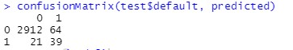

**Practical 4 a Decision Tree**

**Get ElemStatLearn package from <https://cran.r-project.org/src/contrib/Archive/ElemStatLearn/>****as shown below:**

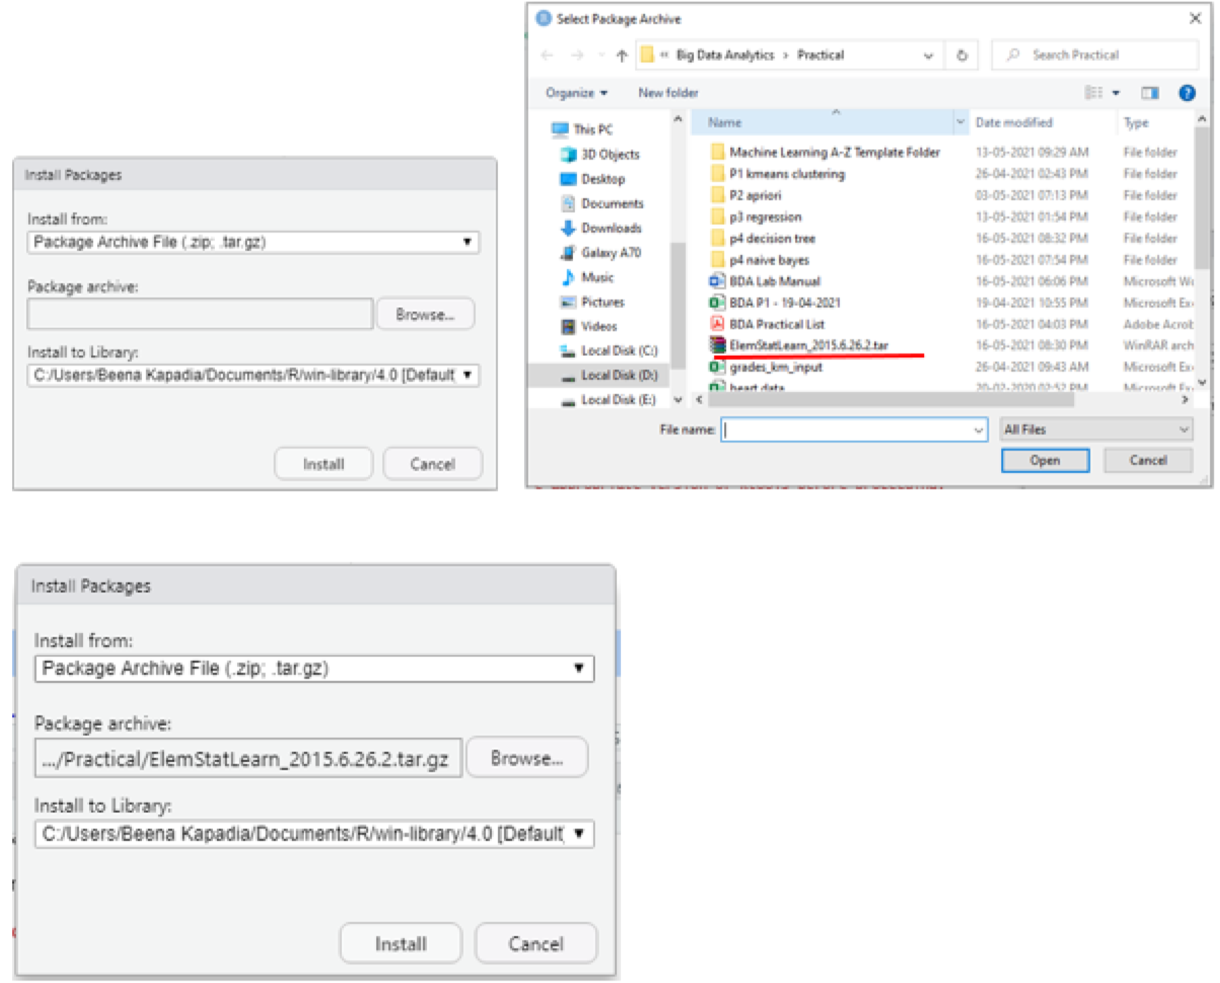

**Code:**

# Decision Tree Classification

# Importing the dataset

dataset = read.csv('D:\\2020\\Big Data Analytics\\Practical\\p4 decision tree\\Social_Network_Ads.csv') dataset = dataset[3:5]

# Encoding the target feature as factor

dataset$Purchased = factor(dataset$Purchased, levels = c(0, 1))

# Splitting the dataset into the Training set and Test set install.packages('caTools') library(caTools) set.seed(123)

split = sample.split(dataset$Purchased, SplitRatio = 0.75) training_set = subset(dataset, split == TRUE)

test_set = subset(dataset, split == FALSE)

# Feature Scaling training_set[-3] = scale(training_set[-3]) test_set[-3] = scale(test_set[-3])

# Fitting Decision Tree Classification to the Training set install.packages('rpart') library(rpart)

classifier = rpart(formula = Purchased ~ ., data = training_set)

# Predicting the Test set results

y_pred = predict(classifier, newdata = test_set[-3], type = 'class')

# Making the Confusion Matrix

cm = table(test_set[, 3], y_pred)

# Visualising the Training set results install.packages("ElemStatLearn") library(ElemStatLearn) set = training_set

X1 = seq(min(set[, 1]) - 1, max(set[, 1]) + 1, by = 0.01) X2 = seq(min(set[, 2]) - 1, max(set[, 2]) + 1, by = 0.01) grid_set = expand.grid(X1, X2) colnames(grid_set) = c('Age', 'EstimatedSalary') y_grid = predict(classifier, newdata = grid_set, type = 'class') plot(set[, -3],

main = 'Decision Tree Classification (Training set)', xlab = 'Age', ylab = 'Estimated Salary', xlim = range(X1), ylim = range(X2)) contour(X1, X2, matrix(as.numeric(y_grid), length(X1), length(X2)), add = TRUE) points(grid_set, pch = '.', col = ifelse(y_grid == 1, 'springgreen3', 'tomato')) points(set, pch = 21, bg = ifelse(set[, 3] == 1, 'green4', 'red3'))

# Visualising the Test set results library(ElemStatLearn) set = test_set

X1 = seq(min(set[, 1]) - 1, max(set[, 1]) + 1, by = 0.01) X2 = seq(min(set[, 2]) - 1, max(set[, 2]) + 1, by = 0.01) grid_set = expand.grid(X1, X2) colnames(grid_set) = c('Age', 'EstimatedSalary') y_grid = predict(classifier, newdata = grid_set, type = 'class') plot(set[, -3], main = 'Decision Tree Classification (Test set)', xlab = 'Age', ylab = 'Estimated Salary', xlim = range(X1), ylim = range(X2)) contour(X1, X2, matrix(as.numeric(y_grid), length(X1), length(X2)), add = TRUE) points(grid_set, pch = '.', col = ifelse(y_grid == 1, 'springgreen3', 'tomato')) points(set, pch = 21, bg = ifelse(set[, 3] == 1, 'green4', 'red3'))

# Plotting the tree

plot(classifier) text(classifier)

**input: Social_Network_Ads.csv**

User ID Gender Age EstimatedSalary Purchased

15624510 Male 19 19000 0

15810944 Male 35 20000 0

15668575 Female 26 43000 0

15603246 Female 27 57000 0

15804002 Male 19 76000 0

15728773 Male 27 58000 0 15598044 Female 27 84000 0

15694829 Female 32 150000 1

15600575 Male 25 33000 0

15727311 Female 35 65000 0

**Output:**

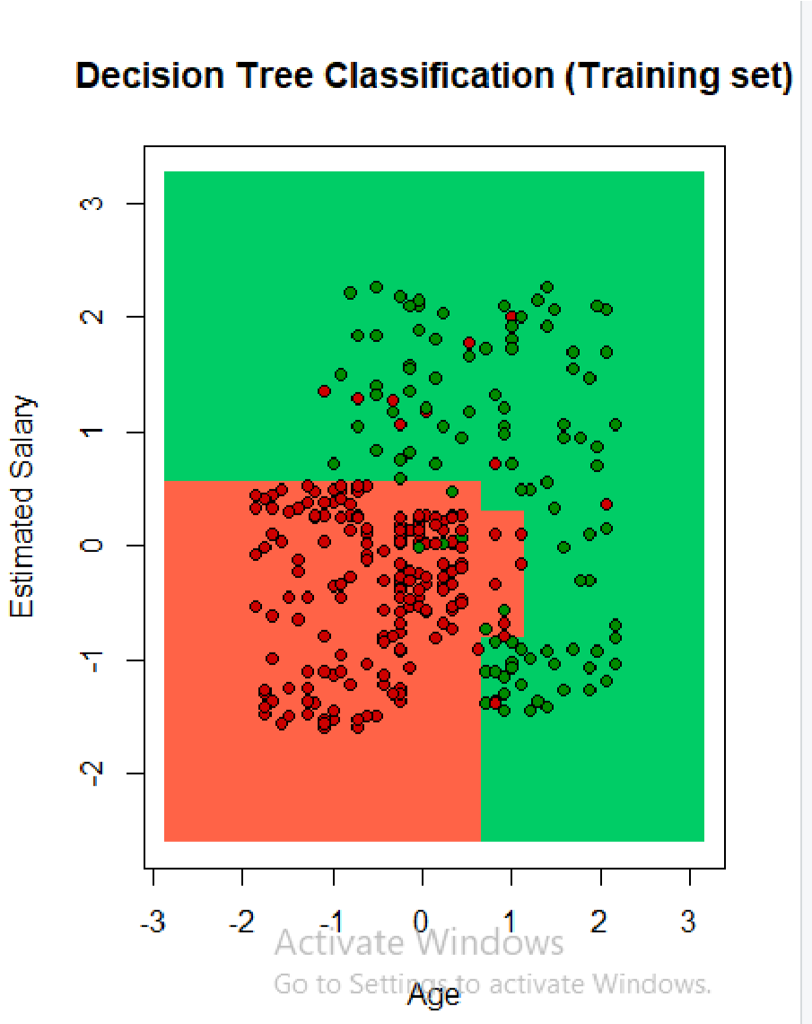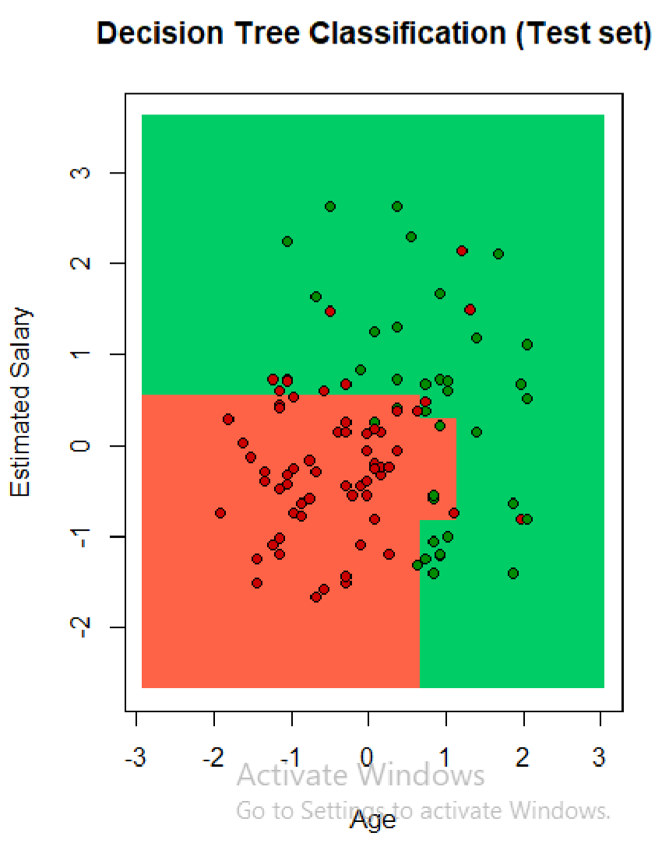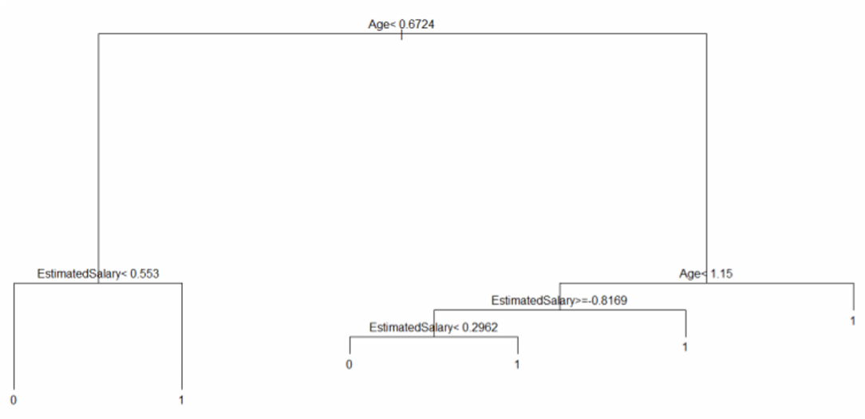

**Practical no: 4b Naïve Bayes Classification**

**Code:**

# Naive Bayes

# Importing the dataset

dataset = read.csv('D:\\2020\\Big Data Analytics\\Practical\\p4 naive bayes\\Social_Network_Ads.csv')

dataset = dataset[3:5]

# Encoding the target feature as factor

dataset$Purchased = factor(dataset$Purchased, levels = c(0, 1))

# Splitting the dataset into the Training set and Test set

#install.packages('caTools') library(caTools) set.seed(123)

split = sample.split(dataset$Purchased, SplitRatio = 0.75) training_set = subset(dataset, split == TRUE)

test_set = subset(dataset, split == FALSE)

# Feature Scaling training_set[-3] = scale(training_set[-3]) test_set[-3] = scale(test_set[-3])

# Fitting Naive Bayes to the Training set install.packages('e1071') library(e1071) classifier = naiveBayes(x = training_set[-3],

y = training_set$Purchased)

# Predicting the Test set results

y_pred = predict(classifier, newdata = test_set[-3])

# Making the Confusion Matrix cm = table(test_set[, 3], y_pred) print(cm)

# Visualising the Training set results install.packages("ElemStatLearn") library(ElemStatLearn) set = training_set print(set)

X1 = seq(min(set[, 1]) - 1, max(set[, 1]) + 1, by = 0.01) X2 = seq(min(set[, 2]) - 1, max(set[, 2]) + 1, by = 0.01) grid_set = expand.grid(X1, X2) colnames(grid_set) = c('Age', 'EstimatedSalary') y_grid = predict(classifier, newdata = grid_set)

plot(set[, -3],

main = 'Naive Bayes (Training set)',

xlab = 'Age', ylab = 'Estimated Salary', xlim = range(X1), ylim = range(X2)) contour(X1, X2, matrix(as.numeric(y_grid), length(X1), length(X2)), add = TRUE) points(grid_set, pch = '.', col = ifelse(y_grid == 1, 'springgreen3', 'tomato')) points(set, pch = 21, bg = ifelse(set[, 3] == 1, 'green4', 'red3'))

# Visualising the Test set results library(ElemStatLearn) set = test_set

X1 = seq(min(set[, 1]) - 1, max(set[, 1]) + 1, by = 0.01) X2 = seq(min(set[, 2]) - 1, max(set[, 2]) + 1, by = 0.01) grid_set = expand.grid(X1, X2) colnames(grid_set) = c('Age', 'EstimatedSalary') y_grid = predict(classifier, newdata = grid_set) plot(set[, -3], main = 'NaiveBayes (Test set)', xlab = 'Age', ylab = 'Estimated Salary', xlim = range(X1), ylim = range(X2)) contour(X1, X2, matrix(as.numeric(y_grid), length(X1), length(X2)), add = TRUE) points(grid_set, pch = '.', col = ifelse(y_grid == 1, 'springgreen3', 'tomato')) points(set, pch = 21, bg = ifelse(set[, 3] == 1, 'green4', 'red3'))

**input: Social_Network_Ads.csv**

User ID Gender Age EstimatedSalary Purchased

15624510 Male 19 19000 0

15810944 Male 35 20000 0 15668575 Female 26 43000 0

15603246 Female 27 57000 0

15804002 Male 19 76000 0

15728773 Male 27 58000 0

15598044 Female 27 84000 0

15694829 Female 32 150000 1

15600575 Male 25 33000 0

15727311 Female 35 65000 0

**Output:**

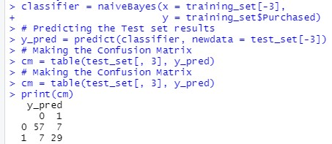

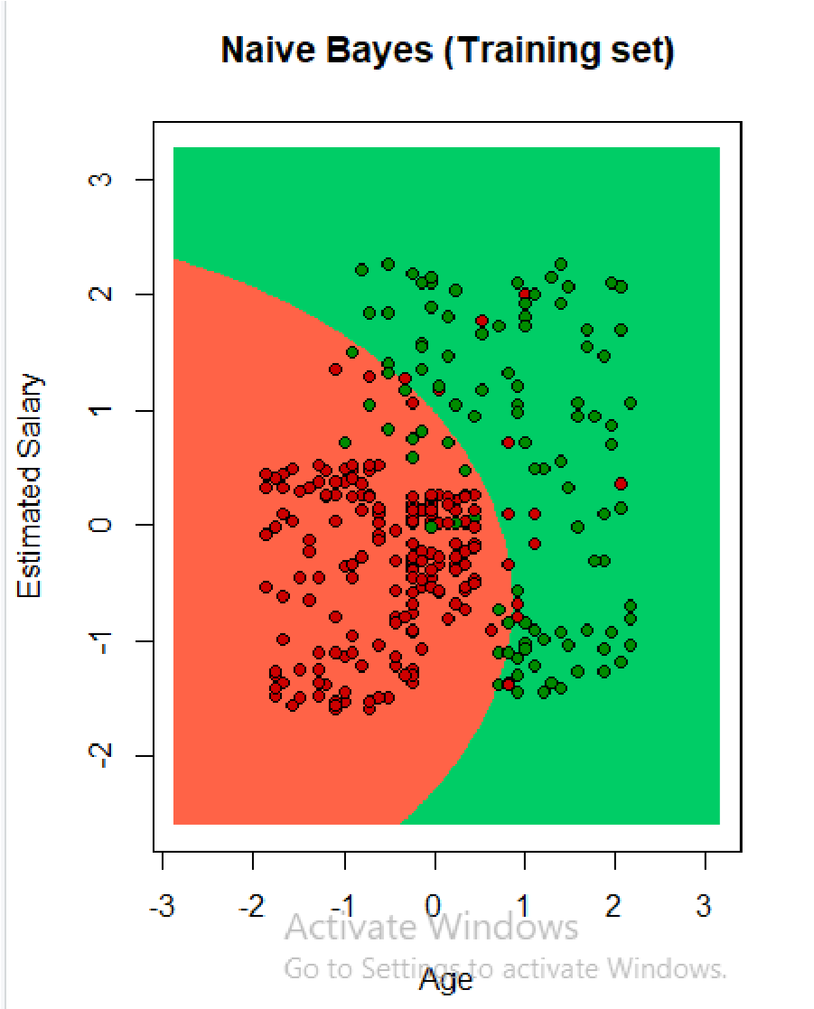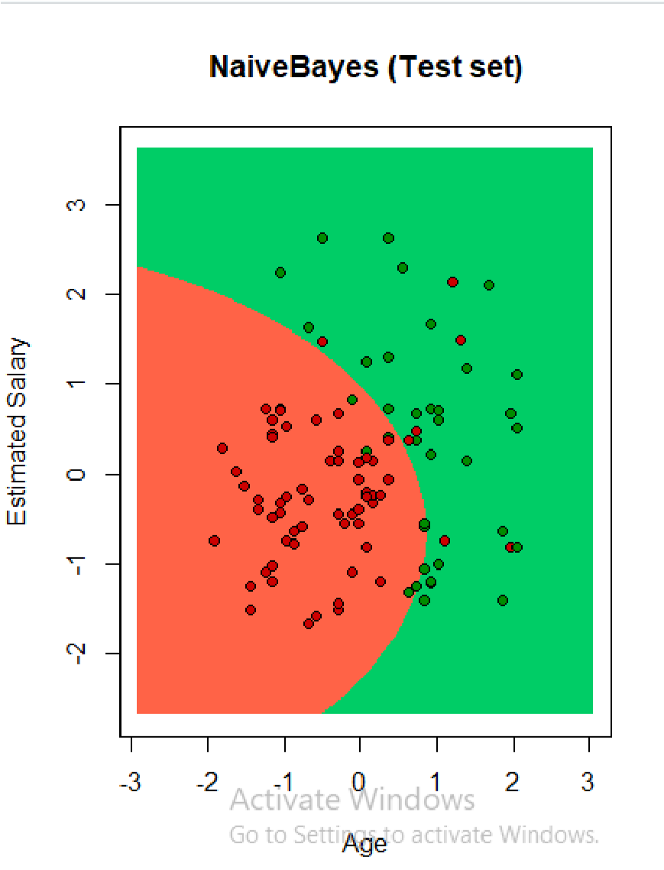

**Practical 5: Text Analysis**

**Code:**

**Natural Language Processing**

# Importing the dataset dataset_original = read.delim('D:\\2020\\Big Data Analytics\\Practical\\P6

NLP\\Restaurant_Reviews.tsv', quote = '', stringsAsFactors = FALSE)

# Cleaning the texts install.packages('tm') install.packages('SnowballC') library(tm) library(SnowballC) corpus = VCorpus(VectorSource(dataset_original$Review)) corpus = tm_map(corpus, content_transformer(tolower)) corpus = tm_map(corpus, removeNumbers) corpus = tm_map(corpus, removePunctuation) corpus = tm_map(corpus, removeWords, stopwords()) corpus = tm_map(corpus, stemDocument)

corpus = tm_map(corpus, stripWhitespace)

# Creating the Bag of Words model dtm = DocumentTermMatrix(corpus) dtm = removeSparseTerms(dtm, 0.999) dataset = as.data.frame(as.matrix(dtm)) dataset$Liked = dataset_original$Liked print(dataset$Liked)

# Encoding the target feature as factor

dataset$Liked = factor(dataset$Liked, levels = c(0, 1))

# Splitting the dataset into the Training set and Test set install.packages('caTools') library(caTools) set.seed(123)

split = sample.split(dataset$Liked, SplitRatio = 0.8) training_set = subset(dataset, split == TRUE)

test_set = subset(dataset, split == FALSE)

# Fitting Random Forest Classification to the Training set install.packages('randomForest') library(randomForest)

classifier = randomForest(x = training_set[-692],

y = training_set$Liked,

ntree = 10)

# Predicting the Test set results

y_pred = predict(classifier, newdata = test_set[-692])

# Making the Confusion Matrix cm = table(test_set[, 692], y_pred) print(cm)

**input** Review Liked

Wow... Loved this place. 1

Crust is not good. 0

Not tasty and the texture was just nasty. 0

Stopped by during the late May bank holiday off Rick Steve recommendation and loved it. 1 The selection on the menu was great and so were the prices. 1

: :

Overall I was not impressed and would not go back. 0

The whole experience was underwhelming, and I think we'll just go to Ninja Sushi next time. 0 Then, as if I hadn't wasted enough of my life there, they poured salt in the wound by drawing out the time it took to bring the check. 0

**Output:**

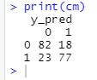

**Practical No.: 6 and 7**

1. **Aim: Install Virtual Box**
2. **Aim: Install, configure, and run Hadoop and HDFS ad explore HDFS.**

**Practical No.: 1**

**Aim: Install, configure and run Hadoop and HDFS ad explore HDFS.**

**Step 1: Download and install VirtualBox**

Go to the website of Oracle VirtualBox and get the latest stable version from the following site https://www.virtualbox.org/ click on ‘Download’’

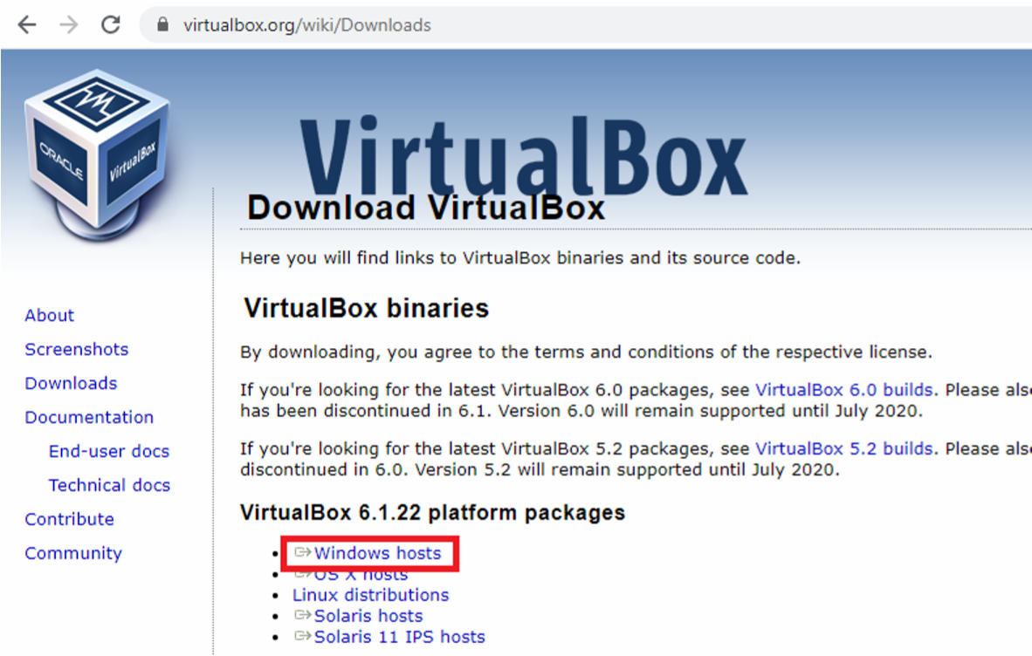

You will get VirtualBox-6.1.22-144080-Win.exe file downloaded. Double click and run it. Click on next.

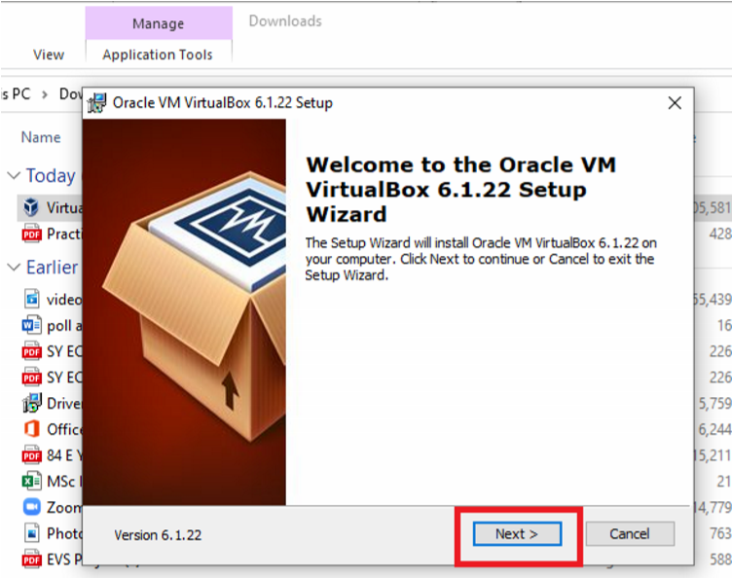

Click on ‘next’ without changing the default folder as shown below:

Again, click on next as shown below:

Finally, click on ‘Yes’.

Click on ’Install’.

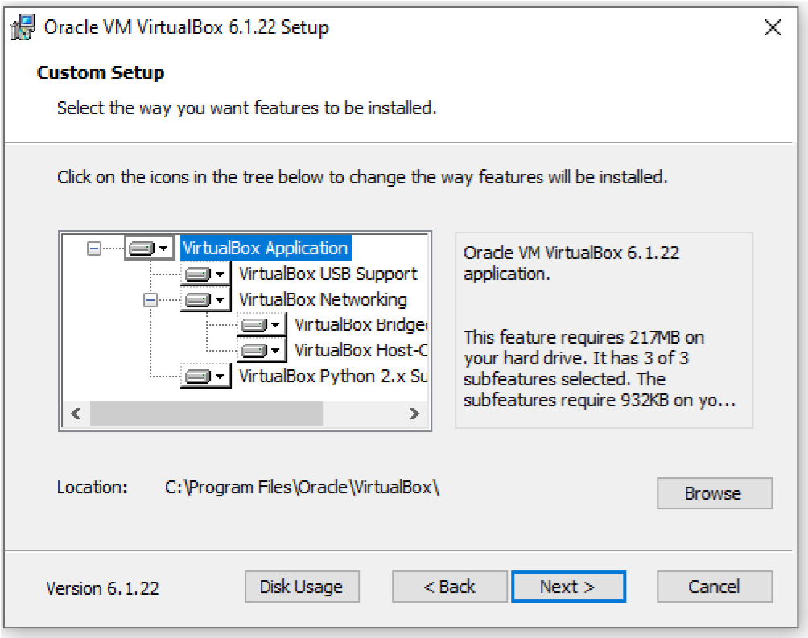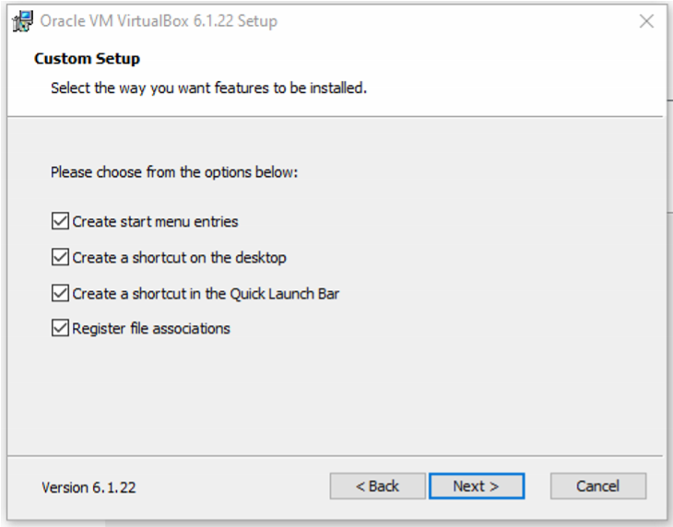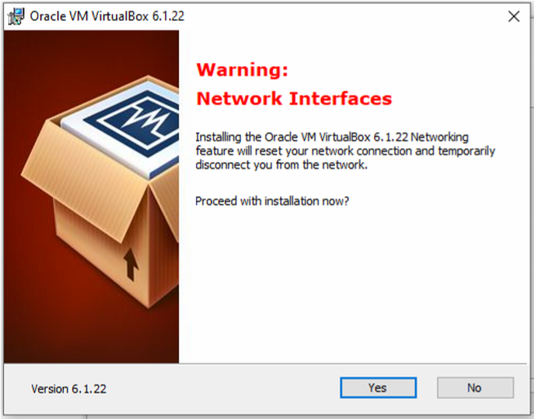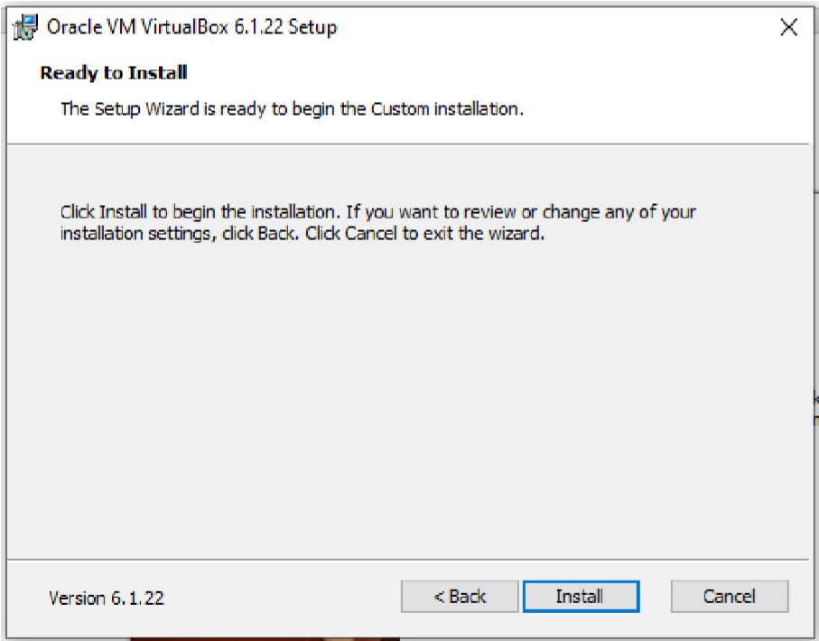

It may ask you for the permission to install, click ’yes’ to allow.

Select ‘Install’ as shown below:

You will get the screen as shown below:

Click on ‘Finish’

to finish Installation of virtual box.

You will get the following screen:

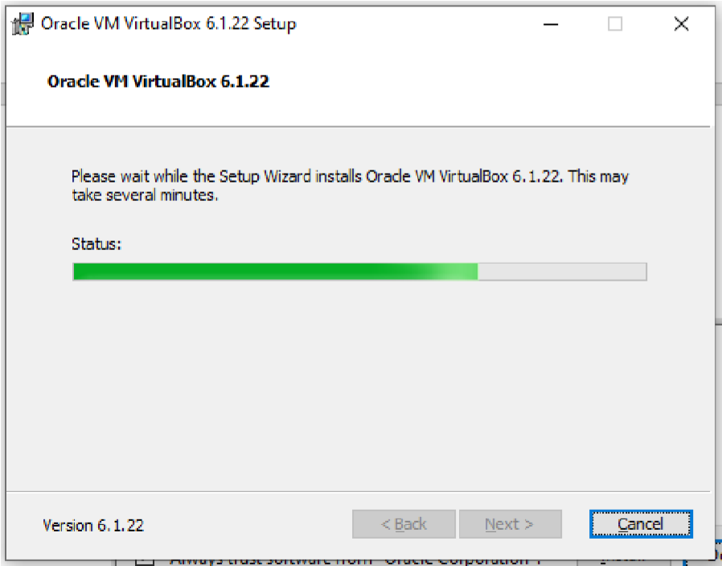

**Step 2: download Ubuntu**

Download iso file ubuntu-20.04.2.0-desktop-amd64; which is required to install Ubuntu.

Browse ubuntu.com

Click on download and 20.04 LTS as shown below:

LTS stands for Long term support

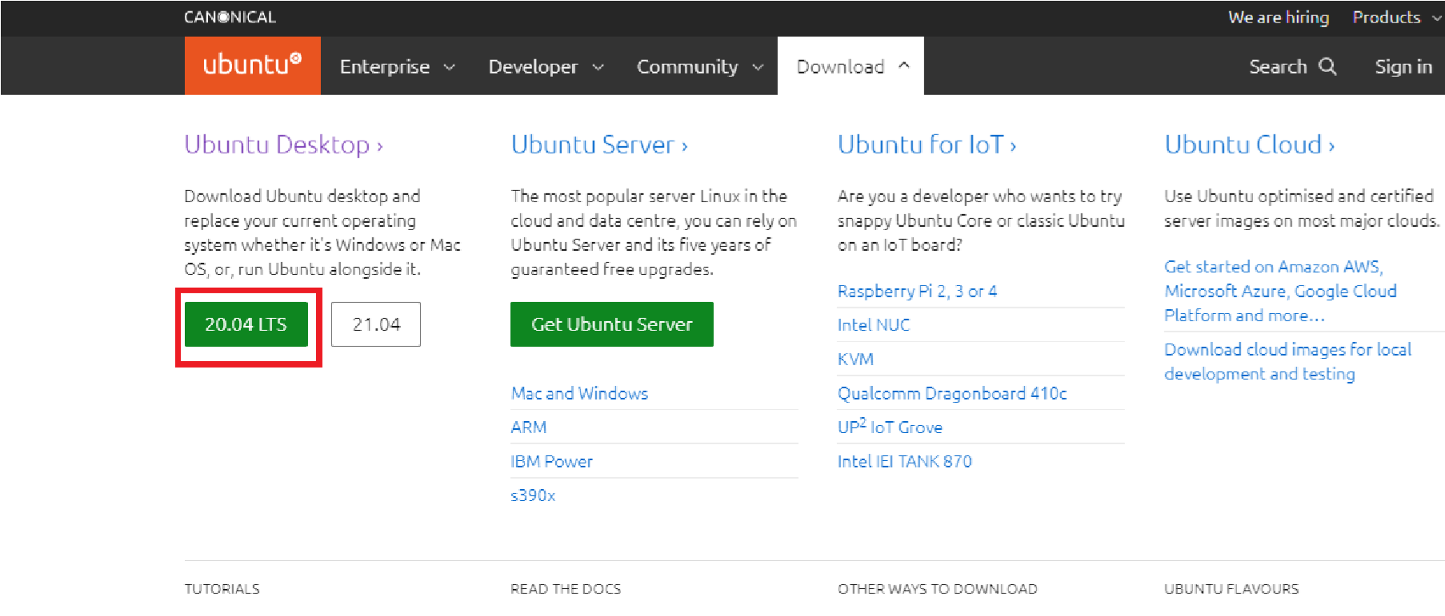

You will get file, which may take few minutes to download.

Now, click on ‘New’ to virtual box and write Name as ‘Ubuntu’ as shown Here, you allow memory size up to green indicator (1970 MB).

below:

Click on ‘Next’.

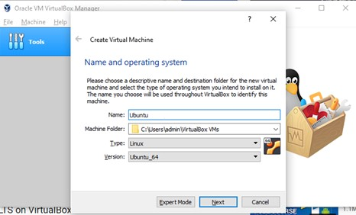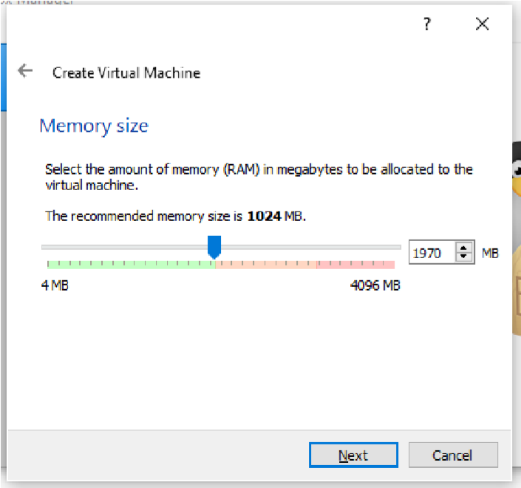

Click on ‘Next’.

Don’t change anything in this screen and click on ‘Create’.



Click on ‘Next’, keeping the selection as it is (on VDI).’



Keep this screen also as it is and click on ‘Next’.

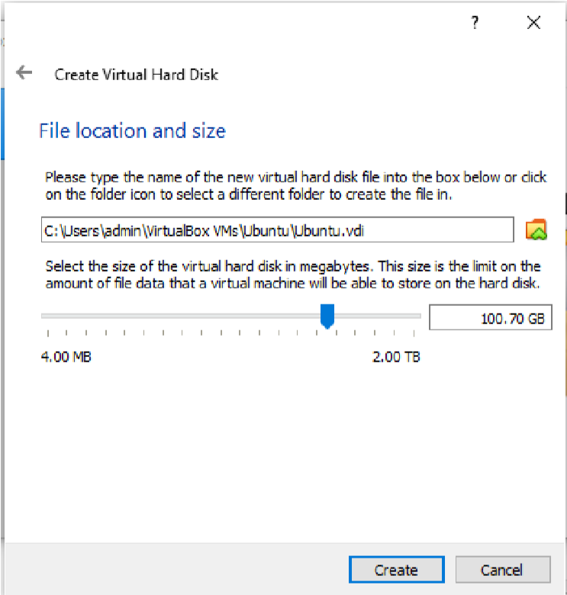

Keep the file location as it is but preferably keep size 100 GB and click on ‘Create’.

You may see the following screen having Ubuntu on Virtual Machine.

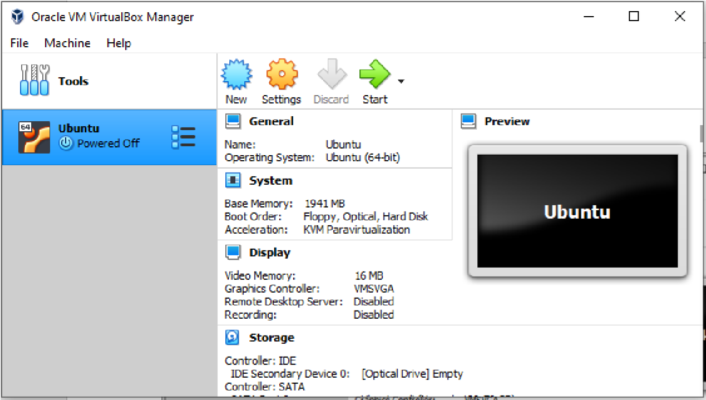

Select ‘settings’

Select ‘General’ -> ’ Basic’ as shown below:

You may change the name from Ubuntu to Ubuntu 20.04

Select bidirectional in ‘General’ -> ’ Advanced’ as shown below:

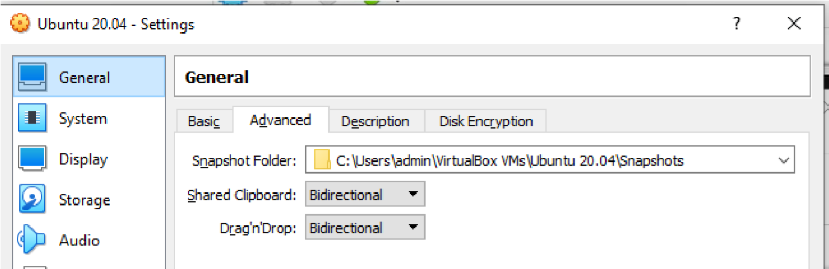

Go to ‘System’ option and change the processor up to green bar, usually 4.(if it allows)

Cut and paste your ubuntu .iso file from current folder to

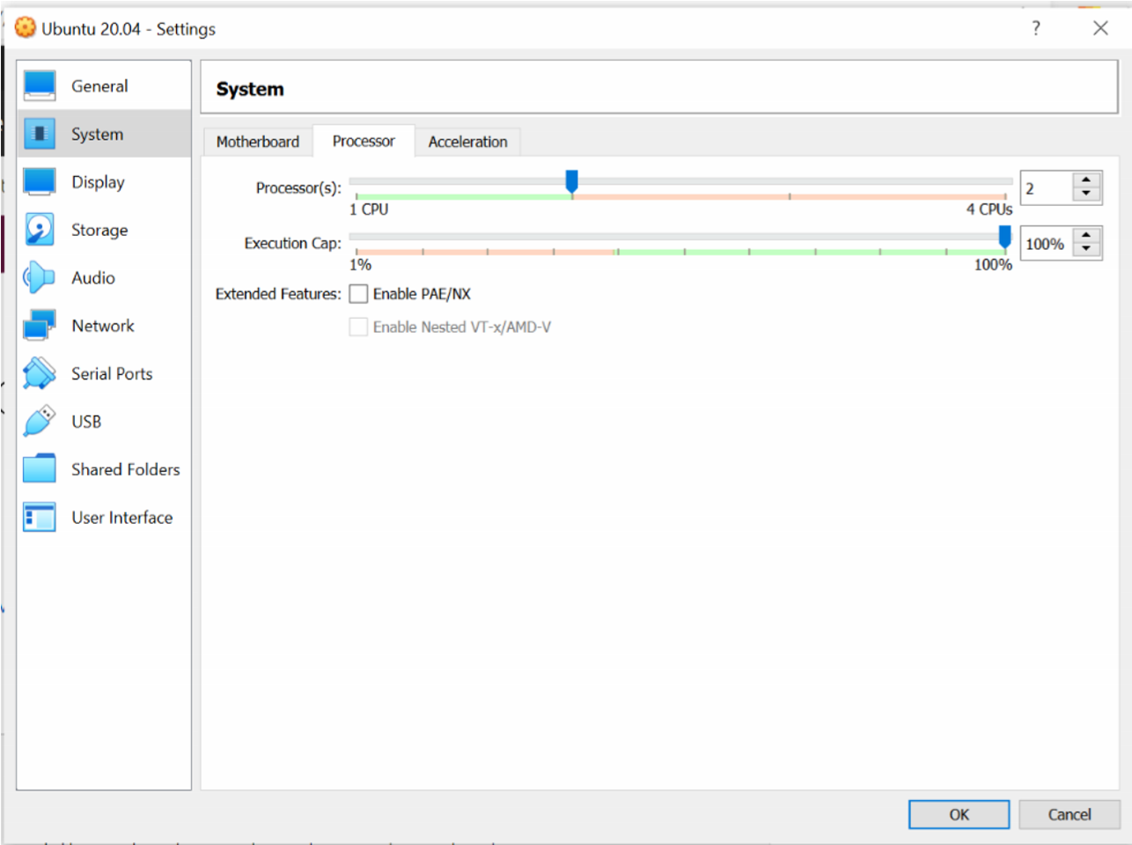C:\Users\ADMIN\VirtualBox VMs\Ubuntu 20.04 folder.

Click on ‘Storage’ and click on ‘Empty’ followed by ‘Choose a disk file’ as shown below:

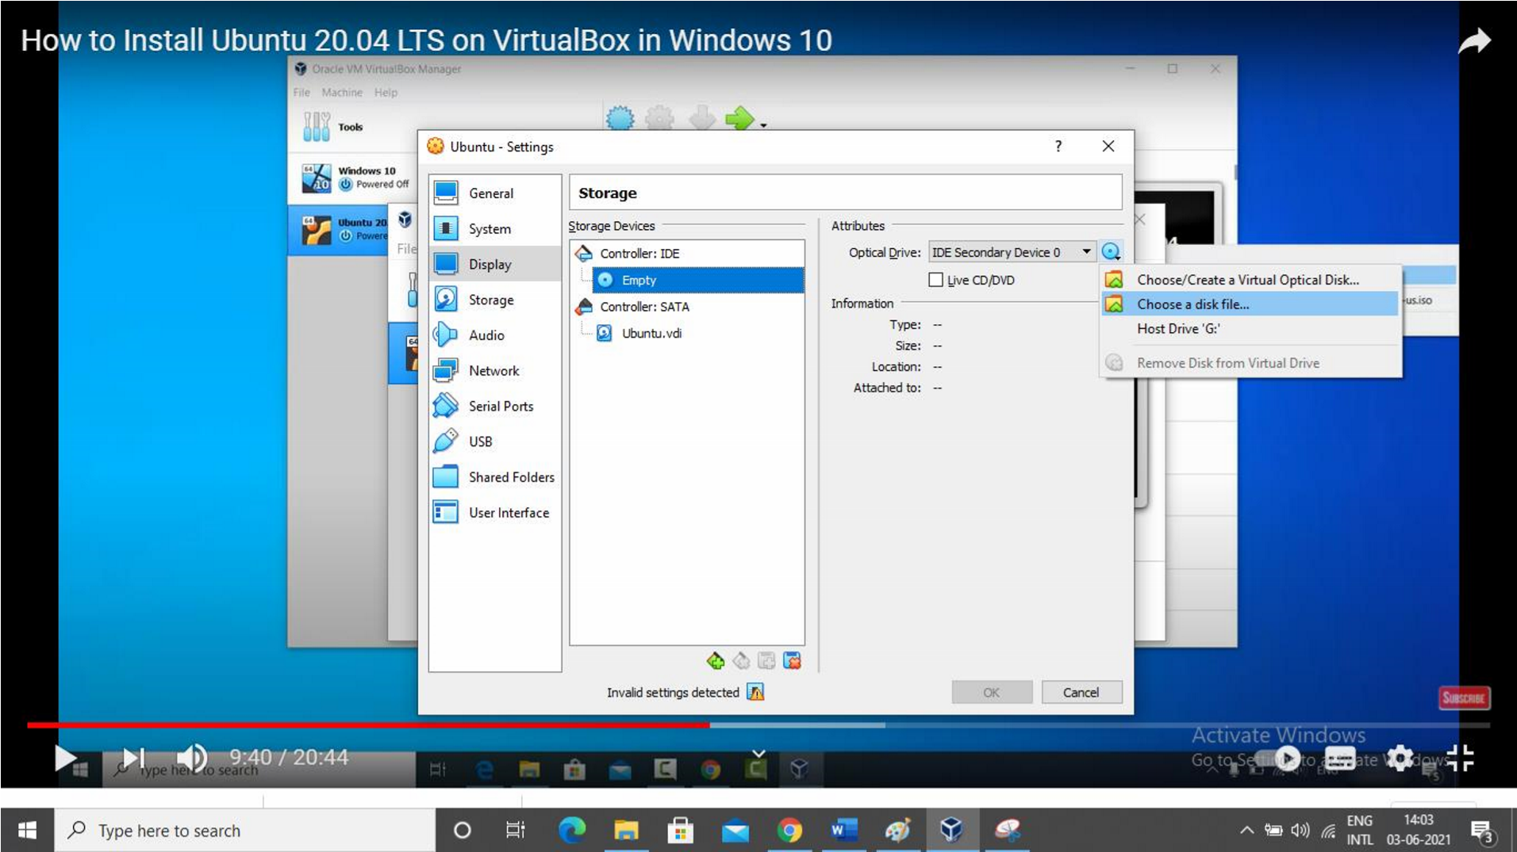

Browse the folder where you have selected ubuntu iso file.

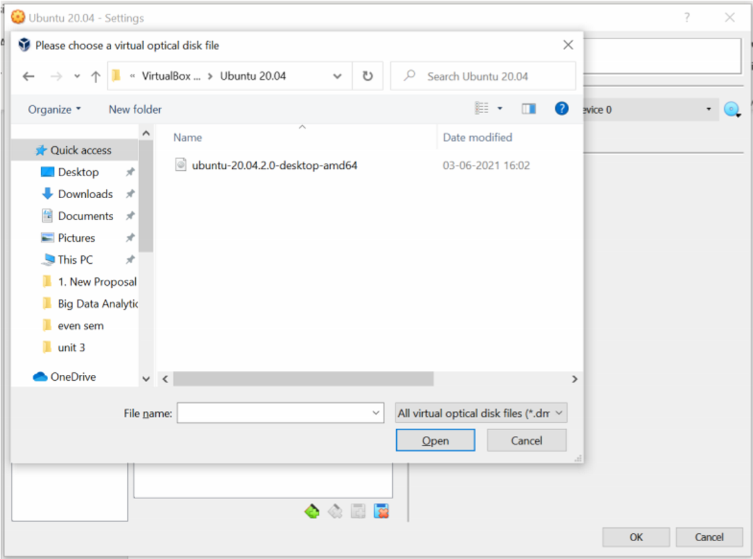

Click on Ubuntu….iso file and click on open and then click on ok.

Click on Ubuntu -> start button.

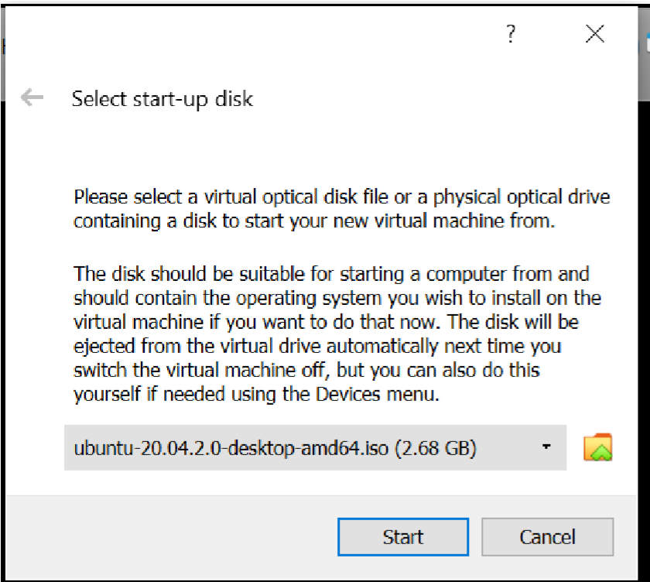

Again, click on ‘Start’ button. It will show you the following screen.

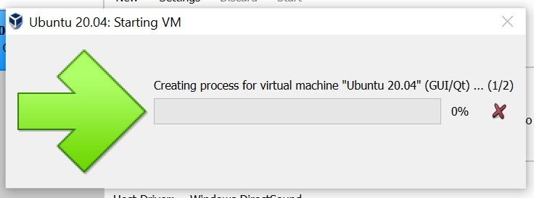

And simultaneously one more screen as follows:

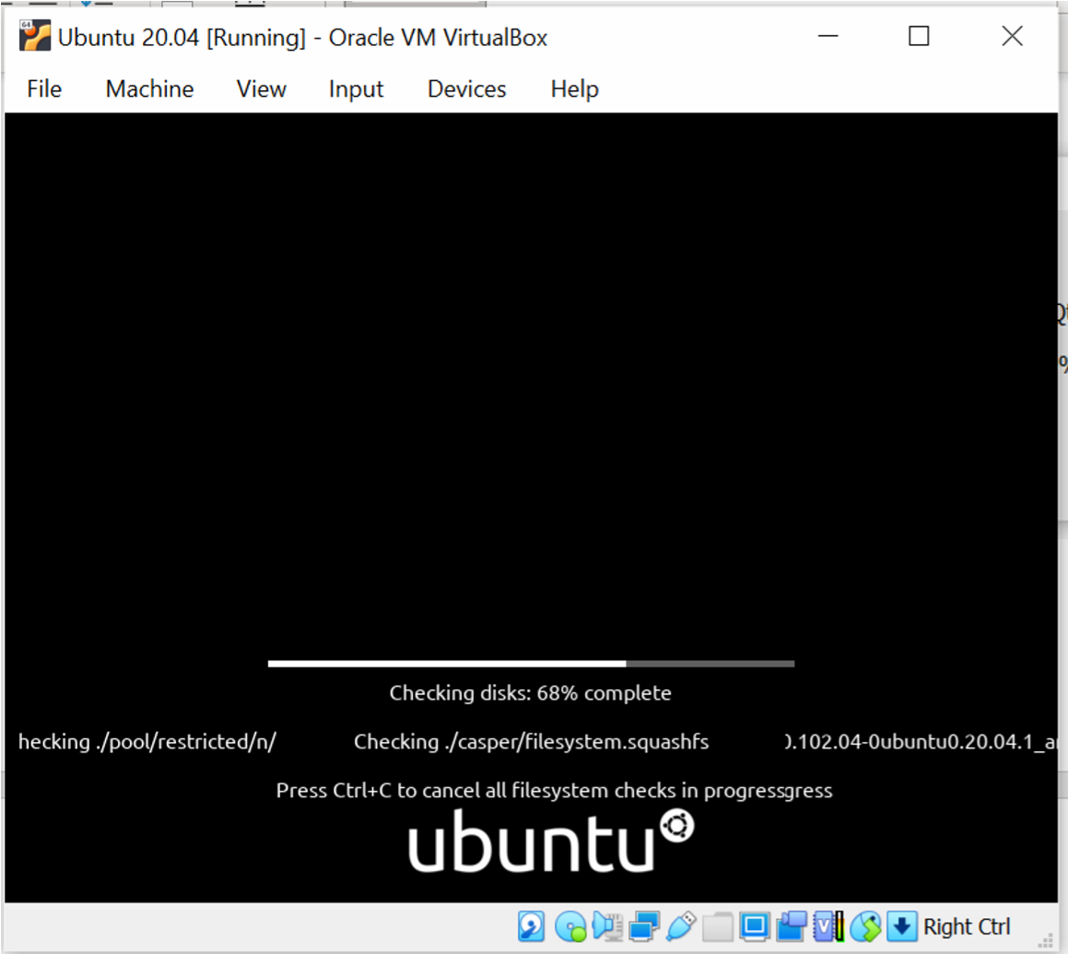

Keep on closing all warnings.

Next you will get following screen automatically.

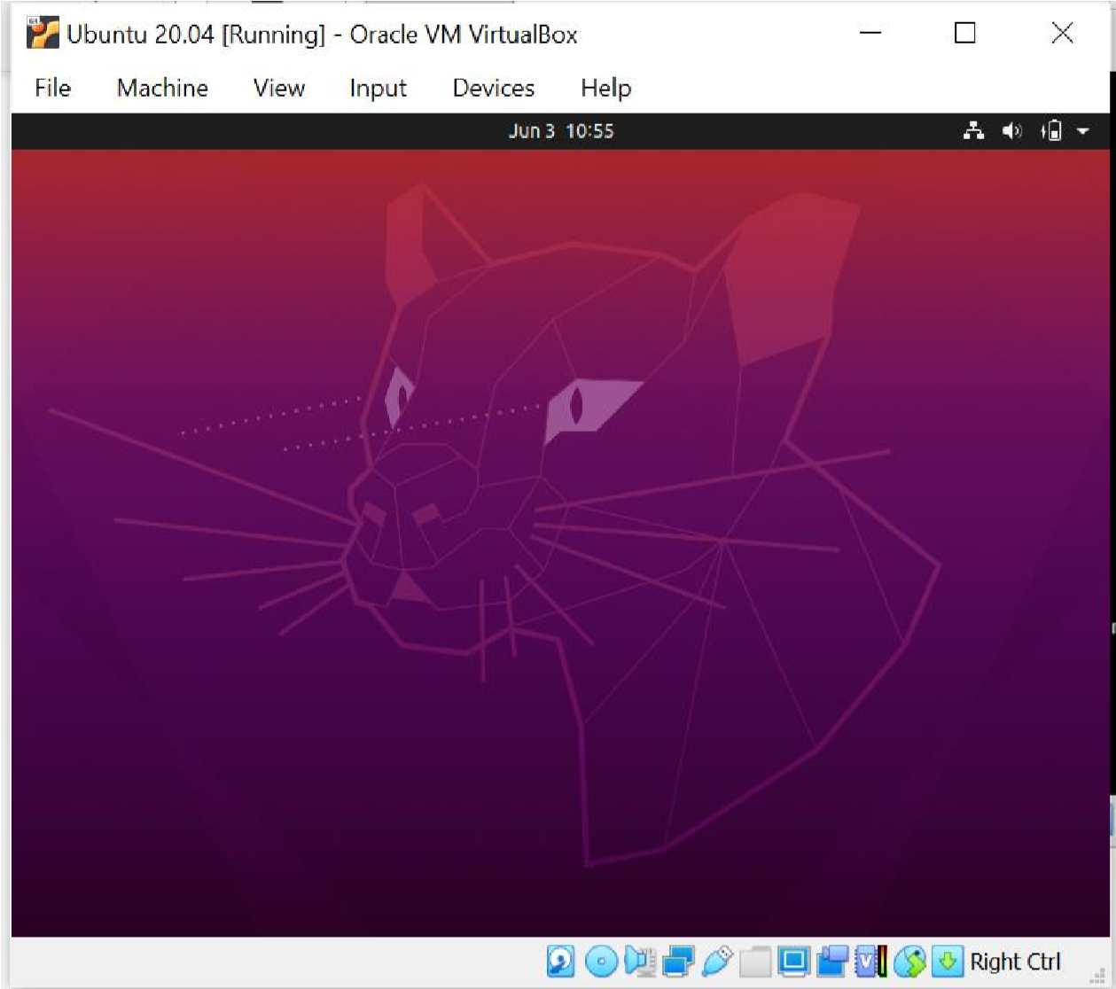

Select language -> English and click on ‘Install Ubuntu’.in ‘Keyboard Layout’ screen, select ‘English UK’. Click on ‘Continue’.

Select the checkbox for third party software as shown below:

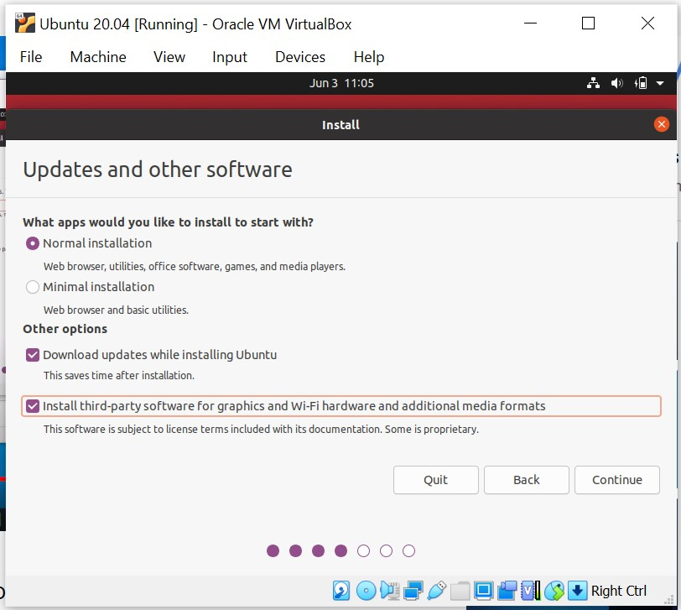

Click on ‘continue’.

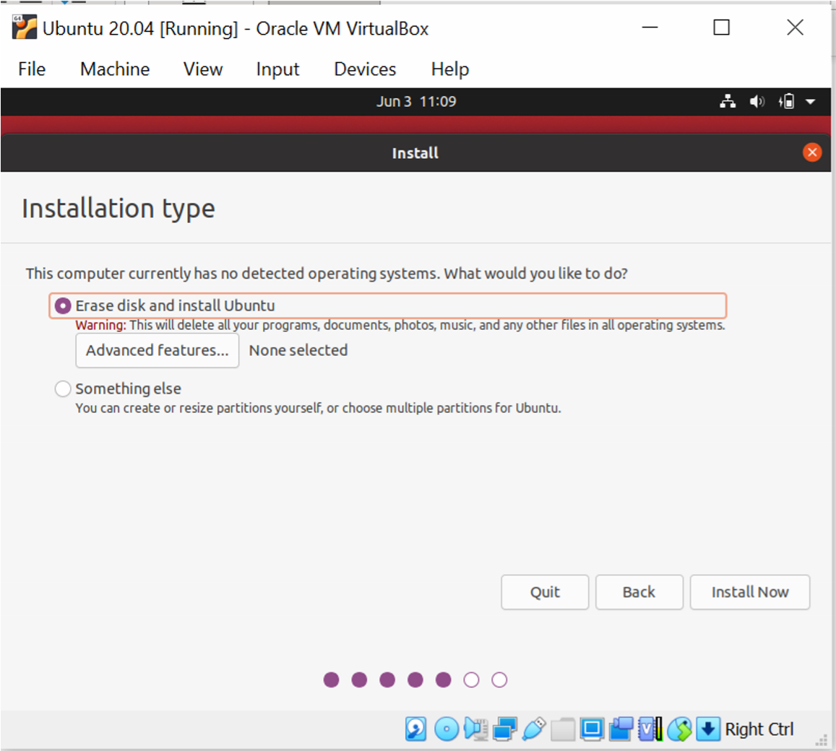

Select Erase disk and Install Ubuntu and click on **‘Install Now’**. Click on **‘Continue’** on the next screen.

Select “Kolkata” for “where are you?” and click on **‘Continue’.**

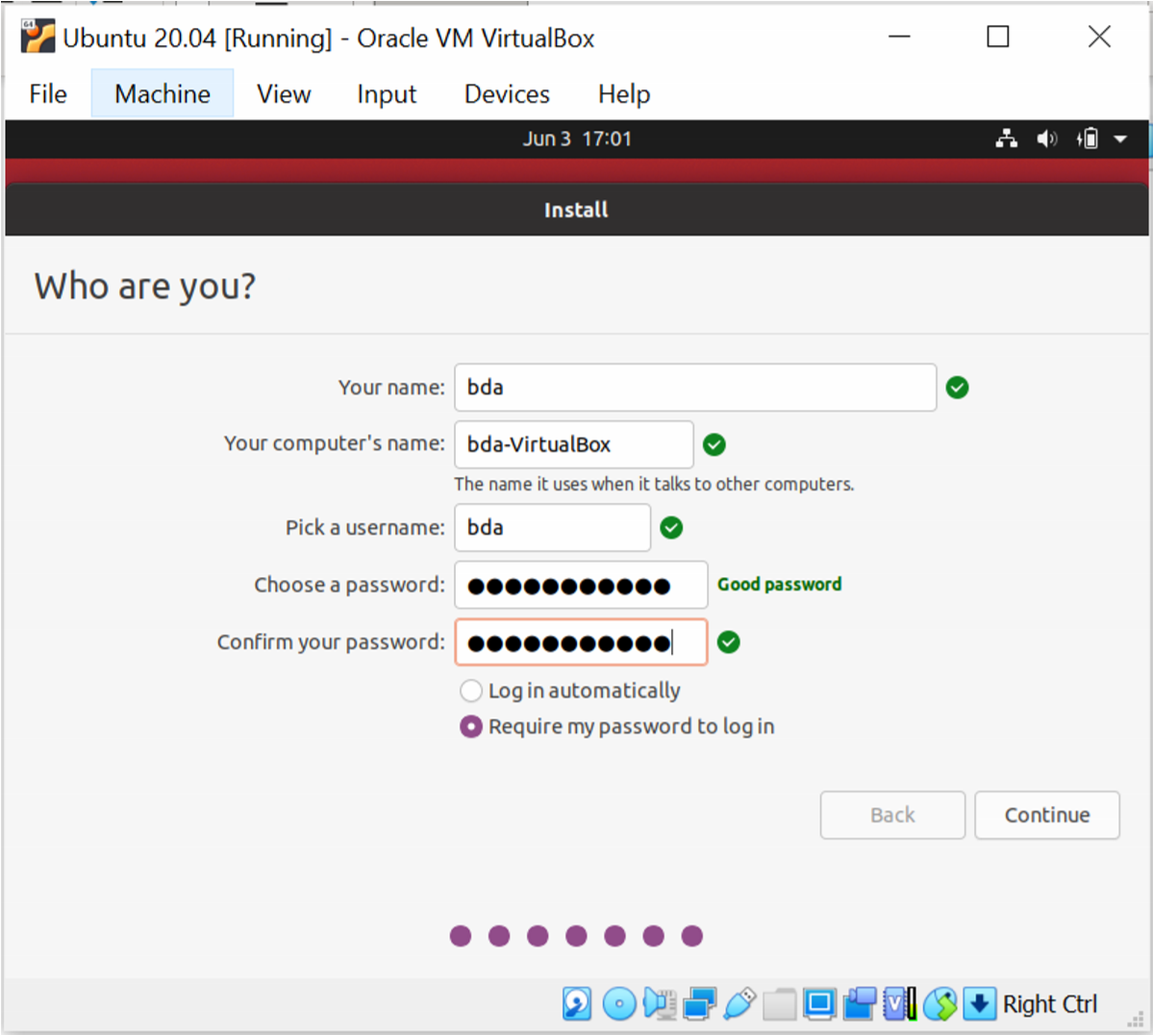

Click on continue after entering name, company name, username, password and confirm your password.

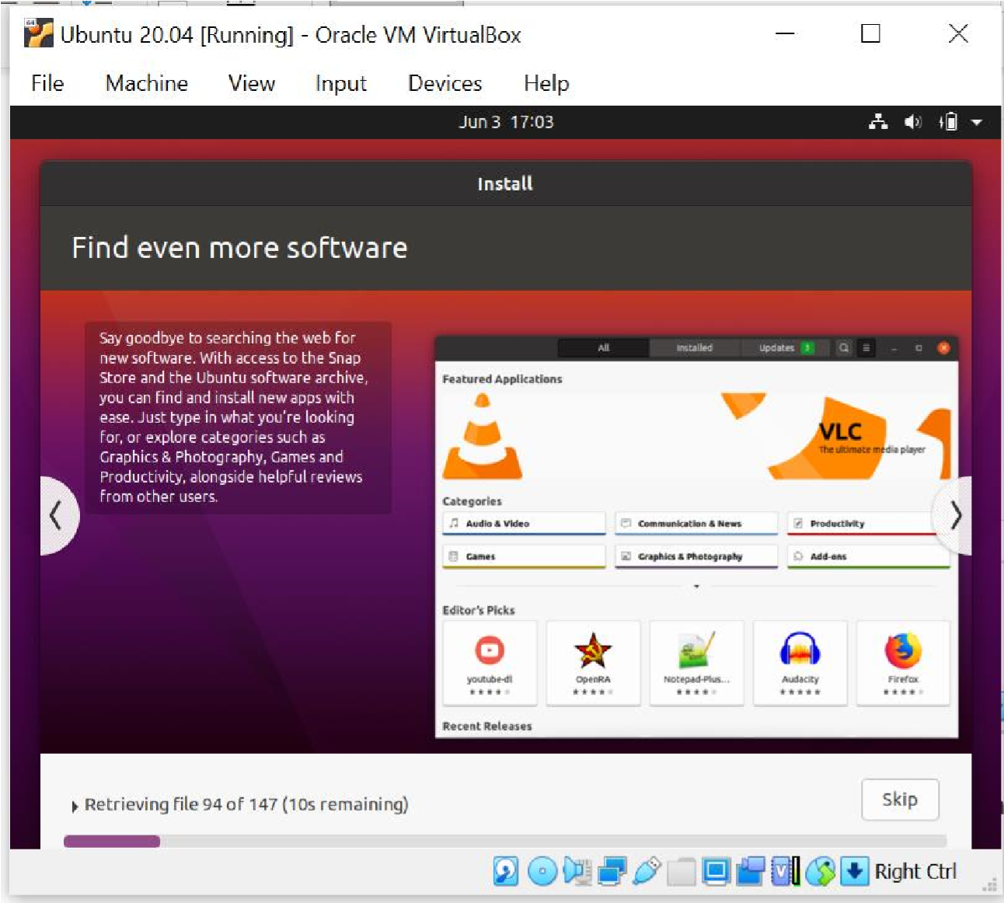

Installation of Ubuntu started. Click on finish once installation done. Click on restart and press Enter key.

**Step 3 Install Hadoop**

Login to ubuntu

Some keys may change like you try to type @ and it types “.

** please refer to note - Some Keys for Ubuntu under UK keyboard layout – at the end.

Search for Ubuntu terminal on search bar, after login done.

Apply following commands from ubuntu terminal

**Prerequisite**

**buntu@ubuntu:~$ sudo apt update**

Ign:1 cdrom://Ubuntu 20.04.2.0 LTS _Focal Fossa_ - Release amd64 (20210209.1) focal InRelease

Hit:2 cdrom://Ubuntu 20.04.2.0 LTS _Focal Fossa_ - Release amd64 (20210209.1) focal Release

Hit:4 http://archive.ubuntu.com/ubuntu focal InRelease

Hit:5 http://archive.ubuntu.com/ubuntu focal-updates InRelease

Hit:6 http://security.ubuntu.com/ubuntu focal-security InRelease Reading package lists... Done

Building dependency tree

Reading state information... Done

291 packages can be upgraded. Run 'apt list --upgradable' to see them.

**bda@bda-VirtualBox:~$ sudo apt install default-jdk**

Reading package lists... Done

Building dependency tree

: etting up default-jdk (2:1.11-72) ... Setting up libxt-dev:amd64 (1:1.1.5-1) ...

**bda@bda-VirtualBox:~$ java -version** openjdk version "11.0.11" 2021-04-20

OpenJDK Runtime Environment (build 11.0.11+9-Ubuntu-0ubuntu2.20.04)

OpenJDK 64-Bit Server VM (build 11.0.11+9-Ubuntu-0ubuntu2.20.04, mixed mode, sharing)

open ssh server

**bda@bda-VirtualBox:~$ sudo apt install openssh-server openssh-client -y**

Reading package lists... Done

Building dependency tree

:

Processing triggers for ufw (0.36-6) ...

**bda@bda-VirtualBox:~$ sudo adduser hdoop** Adding user `hdoop' ...

Adding new group `hdoop' (1000) ...

Adding new user `hdoop' (1000) with group `hdoop' ...

Creating home directory `/home/hdoop' ...

Copying files from `/etc/skel' ...

New password: hdoop Retype new password:

passwd: password updated successfully Changing the user information for hdoop

Enter the new value, or press ENTER for the default

Full Name []:

Room Number []:

Work Phone []:

Home Phone []:

Other []:

Is the information correct? [Y/n] y

**bda@bda-VirtualBox:~$ su - hdoop**

Password: hdoop

**hdoop@bda-VirtualBox:~$ ssh-keygen -t rsa -P '' -f ~/.ssh/id_rsa** Generating public/private rsa key pair.

Created directory '/home/hdoop/.ssh'.

Your identification has been saved in /home/hdoop/.ssh/id_rsa Your public key has been saved in /home/hdoop/.ssh/id_rsa.pub The key fingerprint is:

SHA256:EDxiHTL1r3LUCdKFWc0moPHUh1D8tU6Y0b2rnxuwUtQ hdoop@bda-

VirtualBox

The key's randomart image is:

+---[RSA 3072]----+

| o+=.+X++ . . |

| oo+Oo.= * + .|

| . .+.= = * E.|

| o + .= o. |

| S + = .|

| . . . +. |

| . o . ... |

| o .. o|

| .+.|

+----[SHA256]-----+

**hdoop@bda-VirtualBox:~$ cat ~/.ssh/id_rsa.pub >> ~/.ssh/authorized_keys** **hdoop@bda-VirtualBox:~$ chmod 0600 ~/.ssh/authorized_keys**

**hdoop@bda-VirtualBox:~$ ssh localhost**

The authenticity of host 'localhost (127.0.0.1)' can't be established. ECDSA key fingerprint is

SHA256:4TE4DDAv14vhARPWjZcW3C5UM3X94B7wUudPrT+ZmF0.

Are you sure you want to continue connecting (yes/no/[fingerprint])? yes

:

Ubuntu comes with ABSOLUTELY NO WARRANTY, to the extent permitted by applicable law.

**Downloading Hadoop**

**hdoop@bda-VirtualBox:~$ wget https://downloads.apache.org/hadoop/common/hadoop-3.3.1/hadoop-3.3.1.tar.gz**

--2021-06-14 08:52:00-- https://downloads.apache.org/hadoop/common/hadoop3.3.1/hadoop-3.3.1.tar.gz

Resolving downloads.apache.org (downloads.apache.org)... 88.99.95.219, 135.181.209.10, 135.181.214.104, ...

Connecting to downloads.apache.org (downloads.apache.org)|88.99.95.219|:443... connected.

HTTP request sent, awaiting response... 200 OK

Length: 359196911 (343M) [application/x-gzip]

Saving to: ‘hadoop-3.3.1.tar.gz’

hadoop-3.3.1.tar.gz 100%[==================>] 342.56M 15.4MB/s in 33s

2021-06-14 08:52:34 (10.2 MB/s) - ‘hadoop-3.3.1.tar.gz’ saved [359196911/359196911]

**hdoop@bda-VirtualBox:~$ ls**

hadoop-3.3.1.tar.gz

**hdoop@bda-VirtualBox:~$ tar xzf hadoop-3.3.1.tar.gz** **hdoop@bda-VirtualBox:~$ ls** hadoop-3.3.1 hadoop-3.3.1.tar.gz

**Editing 6 important files for creating a single cluster**

**hdoop@bda-VirtualBox:~$ su - bda** **bda@bda-VirtualBox:~$ sudo adduser hdoop sudo** Adding user `hdoop' to group `sudo' ... Adding user hdoop to group sudo Done.

**bda@bda-VirtualBox:~$ su - hdoop**

**1.**

**hdoop@bda-VirtualBox:~$ sudo nano .bashrc**

File will be opened and add following lines at the end of the file:

#Hadoop Related Options export HADOOP_HOME=/home/hdoop/hadoop-3.3.1 export HADOOP_INSTALL=$HADOOP_HOME export HADOOP_MAPRED_HOME=$HADOOP_HOME export HADOOP_COMMON_HOME=$HADOOP_HOME export HADOOP_HDFS_HOME=$HADOOP_HOME export YARN_HOME=$HADOOP_HOME export HADOOP_COMMON_LIB_NATIVE_DIR=$HADOOP_HOME/lib/native export PATH=$PATH:$HADOOP_HOME/sbin:$HADOOP_HOME/bin export HADOOP_OPTS="-Djava.library.path=$HADOOP_HOME/lib/nativ"

save this file as ctrl x and y. Press enter.

**hdoop@bda-VirtualBox:~$ source ~/.bashrc**

**2.**

**Edit hadoop-env.sh File**

The *hadoop-env.sh* file serves as a master file to configure YARN, [HDFS,](https://phoenixnap.com/kb/what-is-hdfs) [MapReduce,](https://phoenixnap.com/kb/hadoop-mapreduce) and Hadoop-related project settings.

When setting up a **single node Hadoop cluster**, you need to define which Java implementation is to be utilized. Use the previously created **$HADOOP_HOME** variable to access the *hadoop-env.sh* file:

**hdoop@bda-VirtualBox:~$ sudo nano $HADOOP_HOME/etc/hadoop/hadoop-env.sh** at the end of the file add the following line

**export JAVA_HOME=/usr/lib/jvm/java-11-openjdk-amd64/** save it.

**Edit core-site.xml File**

The *core-site.xml* file defines HDFS and Hadoop core properties.

To set up Hadoop in a pseudo-distributed mode, you need to **specify the URL** for your NameNode, and the temporary directory Hadoop uses for the map and reduce process.

Open the *core-site.xml* file in a text editor:

**hdoop@bda-VirtualBox:~$ sudo nano $HADOOP_HOME/etc/hadoop/core-site.xml**

<configuration>

<property>

<name>hadoop.tmp.dir</name>

<value>/home/hdoop/tmpdata</value>

</property>

<property>

<name>fs.default.name</name>

<value>hdfs://localhost:9000</value>

</property>

</configuration>

**4**

**hdoop@bda-VirtualBox:~$ sudo nano $HADOOP_HOME/etc/hadoop/hdfs-site.xml**

<configuration>

<property>

<name>dfs.data.dir</name>

<value>/home/hdoop/dfsdata/namenode</value>

</property>

<property>

<name>dfs.data.dir</name>

<value>/home/hdoop/dfsdata/datanode</value>

</property>

<property>

<name>dfs.replication</name>

<value>1</value>

</property> </configuration>

**5**

**hdoop@bda-VirtualBox:~$ sudo nano $HADOOP_HOME/etc/hadoop/mapred-site.xml** <configuration>

<property>

<name>mapreduce.framework.name</name>

<value>yarn</value>

</property>

</configuration>

**6**

**hdoop@bda-VirtualBox:~$ sudo nano $HADOOP_HOME/etc/hadoop/yarn-site.xml** <configuration>

<property>

<name>yarn.nodemanager.aux-services</name>

<value>mapreduce_shuffle</value>

</property>

<property>

<name>yarn.nodemanager.aux-services.mapreduce.shuffle.class</name>

<value>org.apache.hadoop.mapred.ShuffleHandler</value>

</property>

<property>

<name>yarn.resourcemanager.hostname</name>

<value>127.0.0.1</value>

</property>

<property>

<name>yarn.acl.enable</name>

<value>0</value>

</property>

<property>

<name>yarn.nodemanager.env-whitelist</name>

< value>JAVA_HOME,HADOOP_COMMON_HOME,HADOOP_HDFS_HOME,HADOOP

_CONF_DIR,CLASSPATH_PERPEND_DISTCACHE,HADOOP_YARN_HOME,HADOO

P_MAPRED_HOME</value>

</property>

</configuration>

# Format HDFS NameNode hdoop@bda-VirtualBox:~$ hdfs namenode -format

: xid=0 when meet shutdown.

2021-06-18 14:16:33,353 INFO namenode.NameNode: SHUTDOWN_MSG:

/************************************************************

SHUTDOWN_MSG: Shutting down NameNode at bda-VirtualBox/127.0.1.1

************************************************************/

Start Hadoop Cluster (services)

# hdoop@bda-VirtualBox:~$ cd Hadoop-3.3.1 hdoop@bda-VirtualBox:~/Hadoop-3.3.1$ cd sbin hdoop@bda-VirtualBox:~/hadoop-3.3.1/sbin$ ./start-dfs.sh

Starting namenodes on [localhost]

Starting datanodes

Starting secondary namenodes [bda-VirtualBox] bda-VirtualBox: Warning: Permanently added 'bda-virtualbox' (ECDSA) to the list of known hosts.

2021-06-18 14:26:34,962 WARN util.NativeCodeLoader: Unable to load native-hadoop library for your platform... using builtin-java classes where applicable

hdoop@bda-VirtualBox:~/hadoop-3.3.1/sbin$ ./start-yarn.sh

Starting resourcemanager

Starting nodemanagers

To see all components, we use jps command:

# hdoop@bda-VirtualBox:~/hadoop-3.3.1/sbin$ jps

11744 NodeManager

11616 ResourceManager

12192 Jps

11268 SecondaryNameNode

11077 DataNode

10954 NameNode

# hdoop@bda-VirtualBox:~/hadoop-3.3.1/sbin$ hdfs dfs -ls /

2021-06-18 14:33:24,698 WARN util.NativeCodeLoader: Unable to load native-hadoop library for your platform... using builtin-java classes where applicable

**hdoop@bda-VirtualBox:~/hadoop-3.3.1/sbin$ sudo nano /home/bda/sample.txt** [sudo] password for hdoop: edit the file by adding some text and save and exit

**hdoop@bda-VirtualBox:~/hadoop-3.3.1/sbin$ ls /home/bda/**

Desktop Downloads Pictures sample.txt Videos Documents Music Public Templates

**hdoop@bda-VirtualBox:~/hadoop-3.3.1/sbin$ hdfs dfs -put /home/bda/sample.txt /** 2021-06-18 14:44:24,257 WARN util.NativeCodeLoader: Unable to load native-hadoop library for your platform... using builtin-java classes where applicable

# doop@bda-VirtualBox:~/hadoop-3.3.1/sbin$ hdfs dfs -ls /

2021-06-18 14:48:17,221 WARN util.NativeCodeLoader: Unable to load native-hadoop library for your platform... using builtin-java classes where applicable

Found 1 items

-rw-r--r-- 1 hdoop supergroup 6 2021-06-18 14:44 /sample.txt

**\*\*Note:**

**Some Keys for Ubuntu under UK keyboard layout**

“ -> @

@ -> “

pipe -> take from this file or on google search for pipe in linux ~ -> pipe